**SAA PROJECT**

NAME:- S RAGHAVA

ID No:-200031834

SEC:-14

**Project**:-Launch a Drupal Website.

**Drupal Website:**-Drupal is free, open source software that can be used by individuals or groups of users -- even those lacking technical skills -- to easily create and manage many types of Web sites.

Step1:-Create an Amazon Lightsail account,if Already have an account then Sign-in.

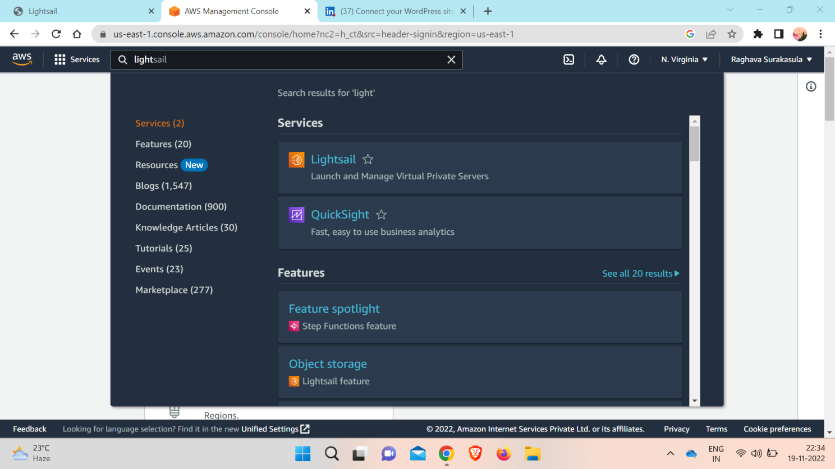

Step 2:-Create a Drupal instance in Amazon Lightsail

a. Choose Create instance in the Instances tab of the Lightsail home page

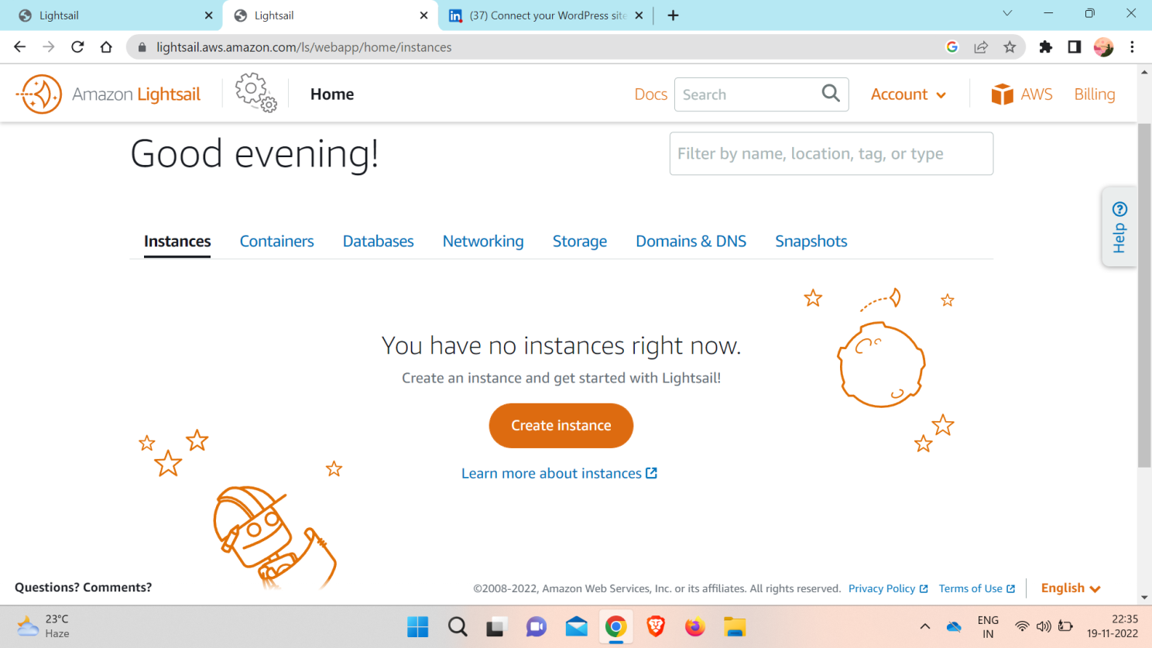

b. Choose the AWS Region and Availability Zone for your instance.

c. Choose your instance image.

*Choose Linux as the platform.

*Choose Drupal as the blueprint.

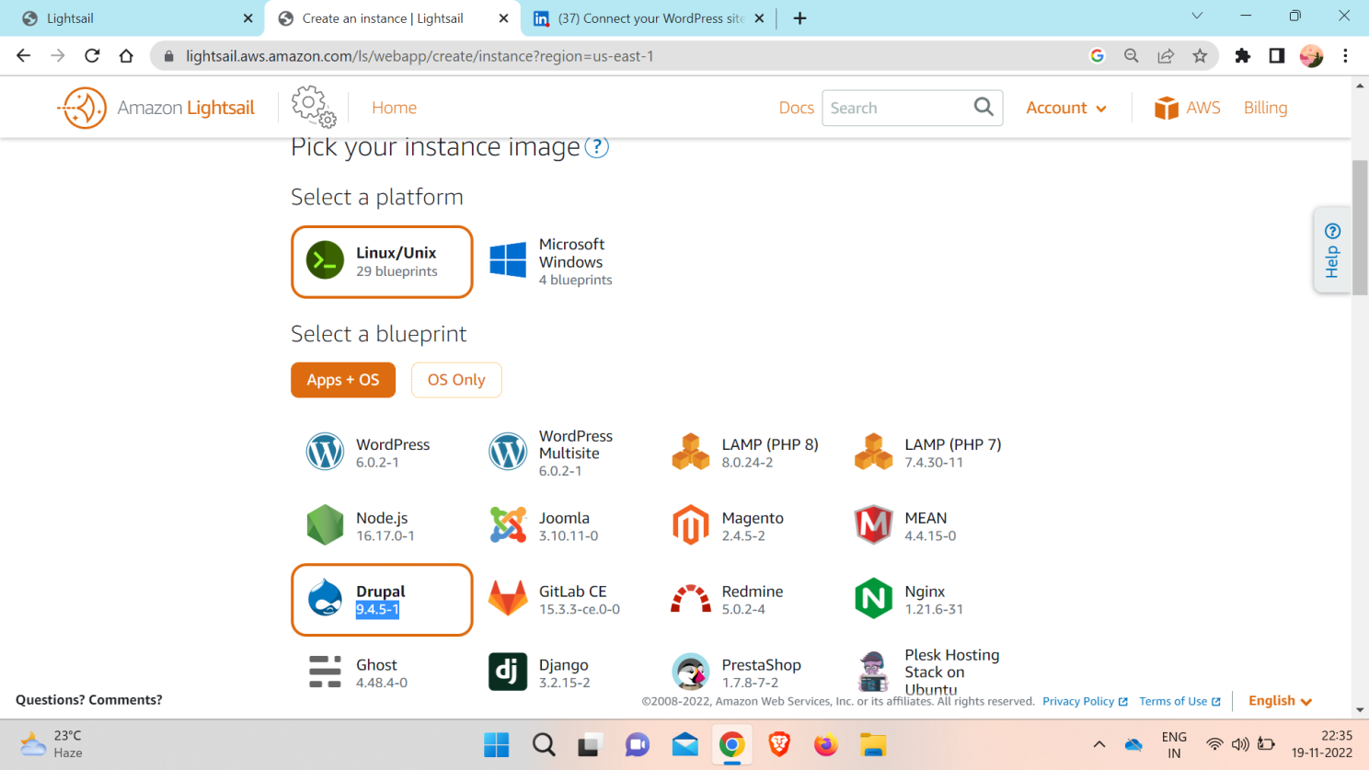

d. Choose an instance plan.

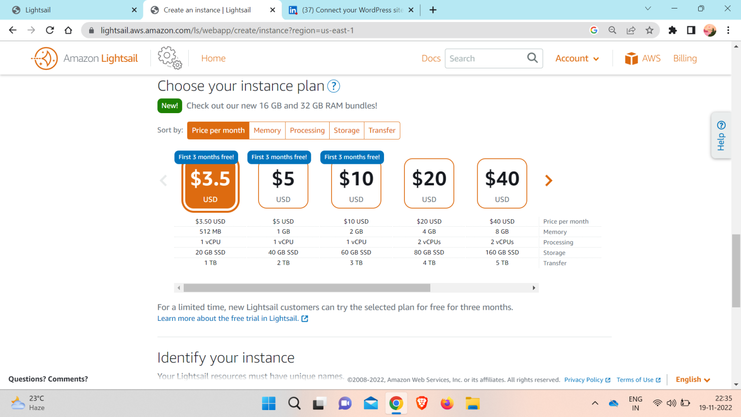

e. Choose Create instance.

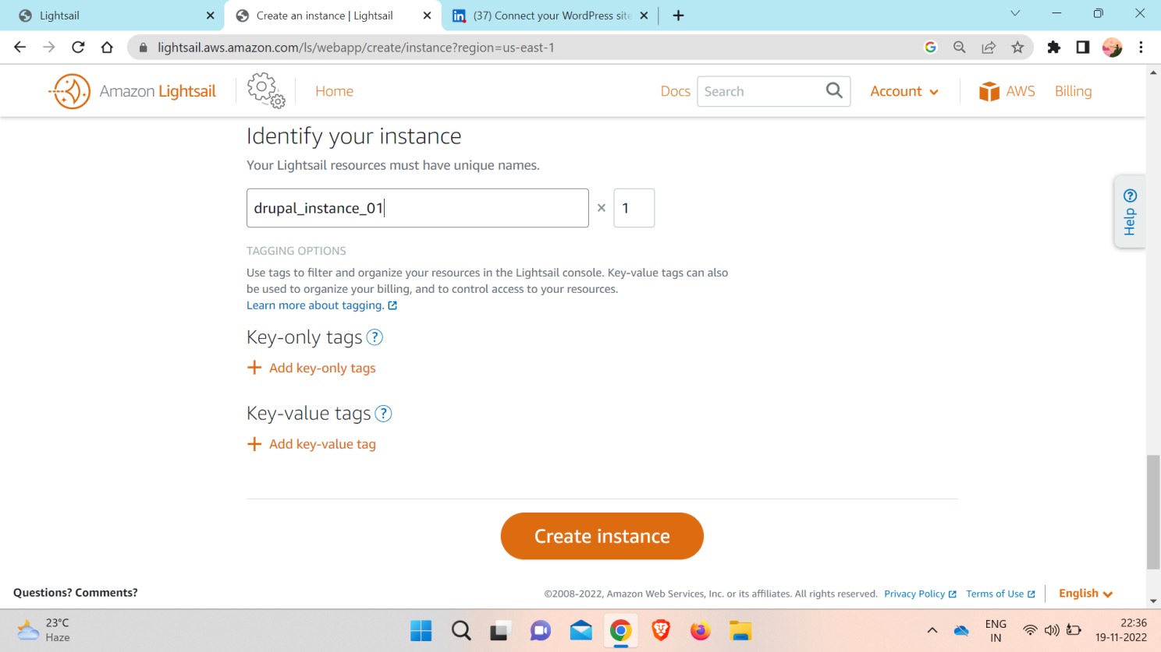

Step 3:- Connect to your instance via SSH and get the password for your Drupal website.

The default password to sign in to your Drupal website is stored on the instance. Complete the following steps to connect to your instance using the browser-based SSH client in the Lightsail console, and get the password to sign in to your Drupal website.

a. On the Instances tab of the Lightsail home page, choose the SSH quick-connect icon for your Drupal instance.

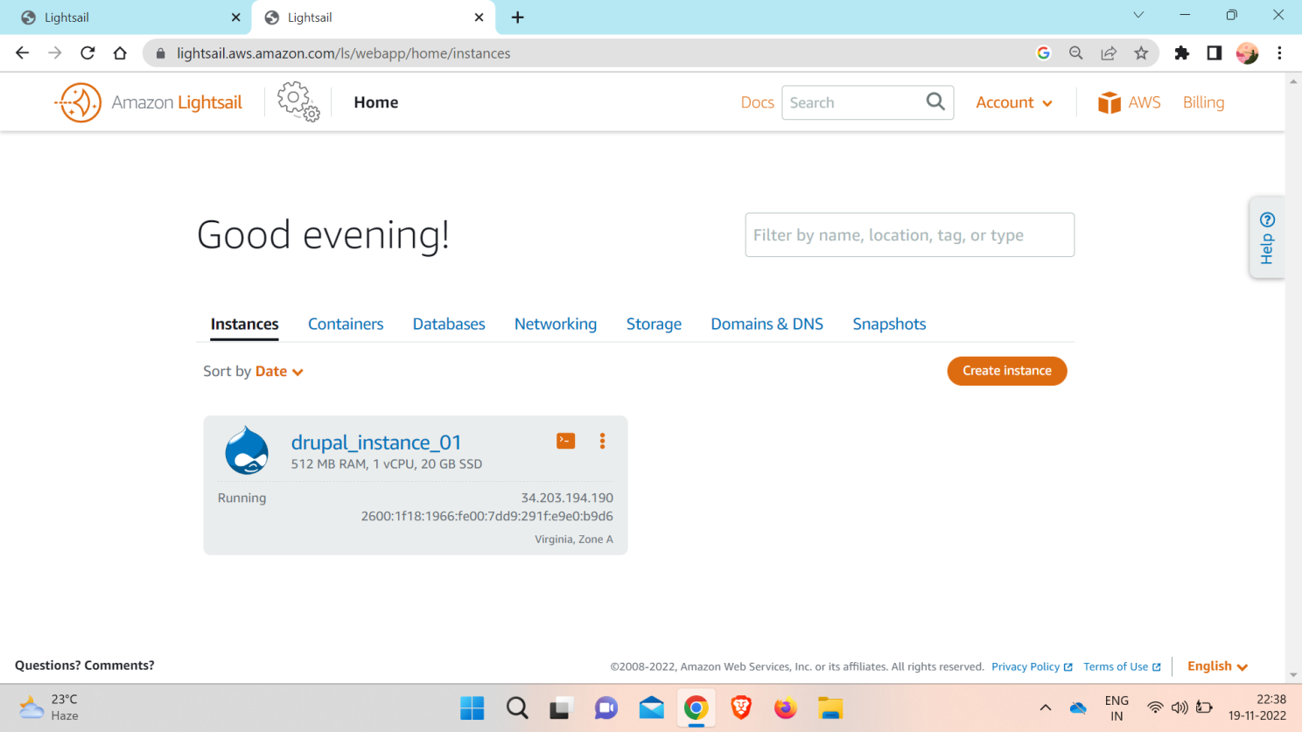

b. After the browser-based SSH client window opens, enter the following command to retrieve the default application password:

**cat $HOME/bitnami_application_password**

c. Make note of the password displayed on the screen. You use it later to sign in to the administration dashboard of your Dupral website and Choose Create instance.

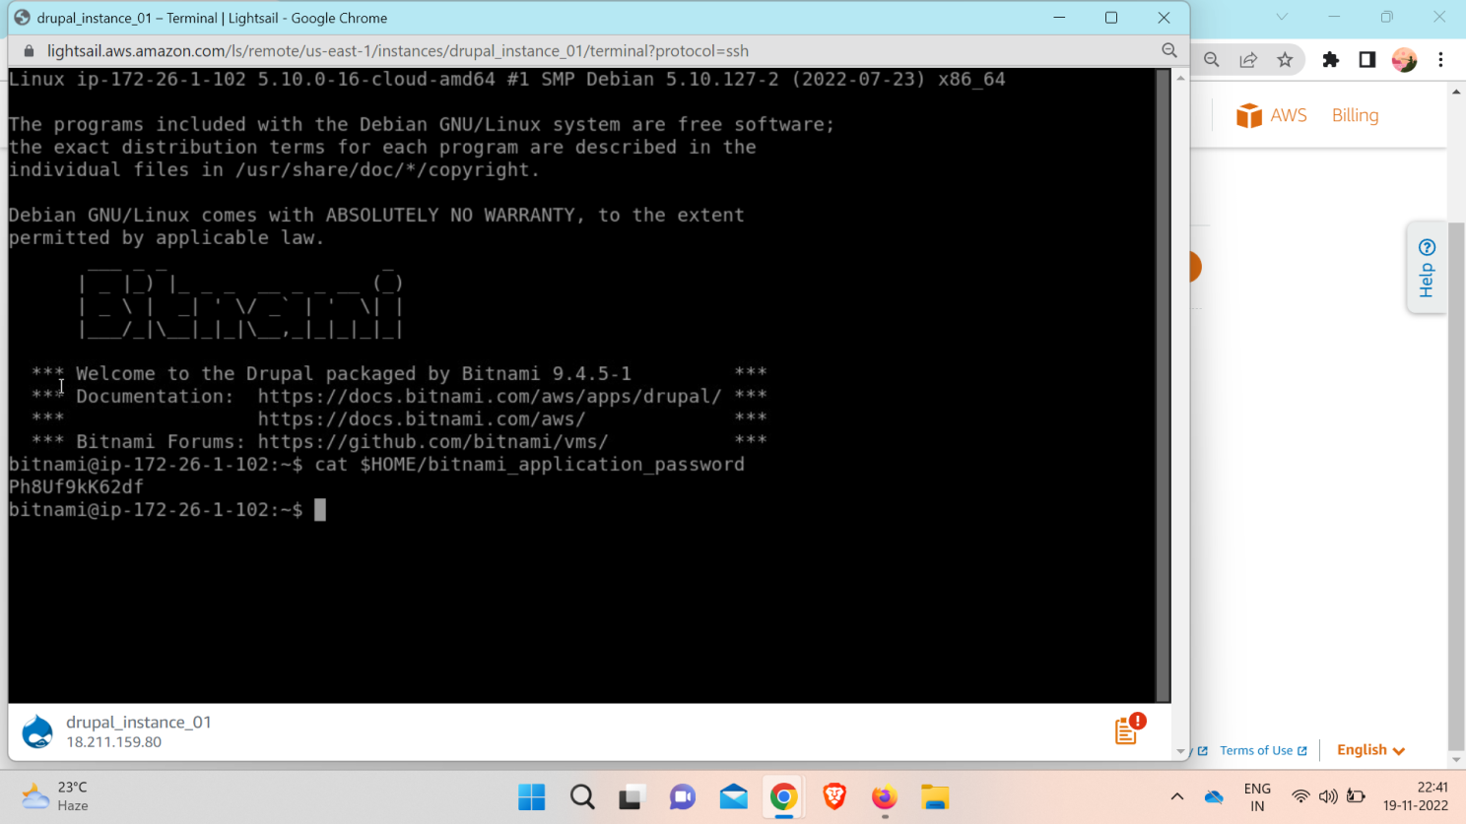

Step 4:- Sign in to your Drupal website

a. In a browser, go to:

**http://PublicIpAddress/user/login**

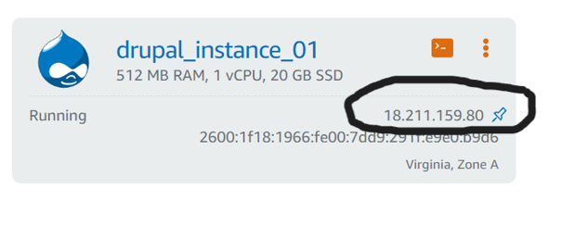

b. Log into your site.

*In the **Username box**, enter user.

*In the**Password box**, enter the password that you have copied from the instance console.

*Choose**Log in.**

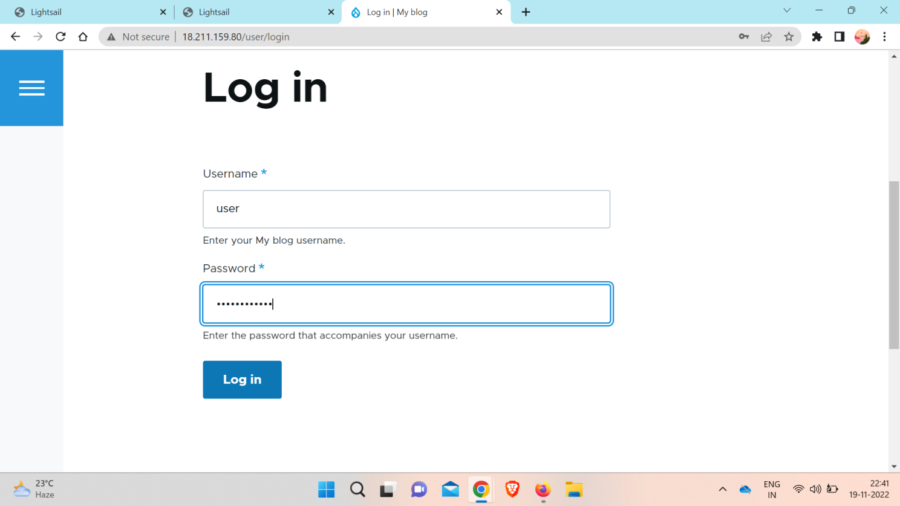

 Step 5:-Create a Lightsail static IP address and attach it to your Drupal instance.

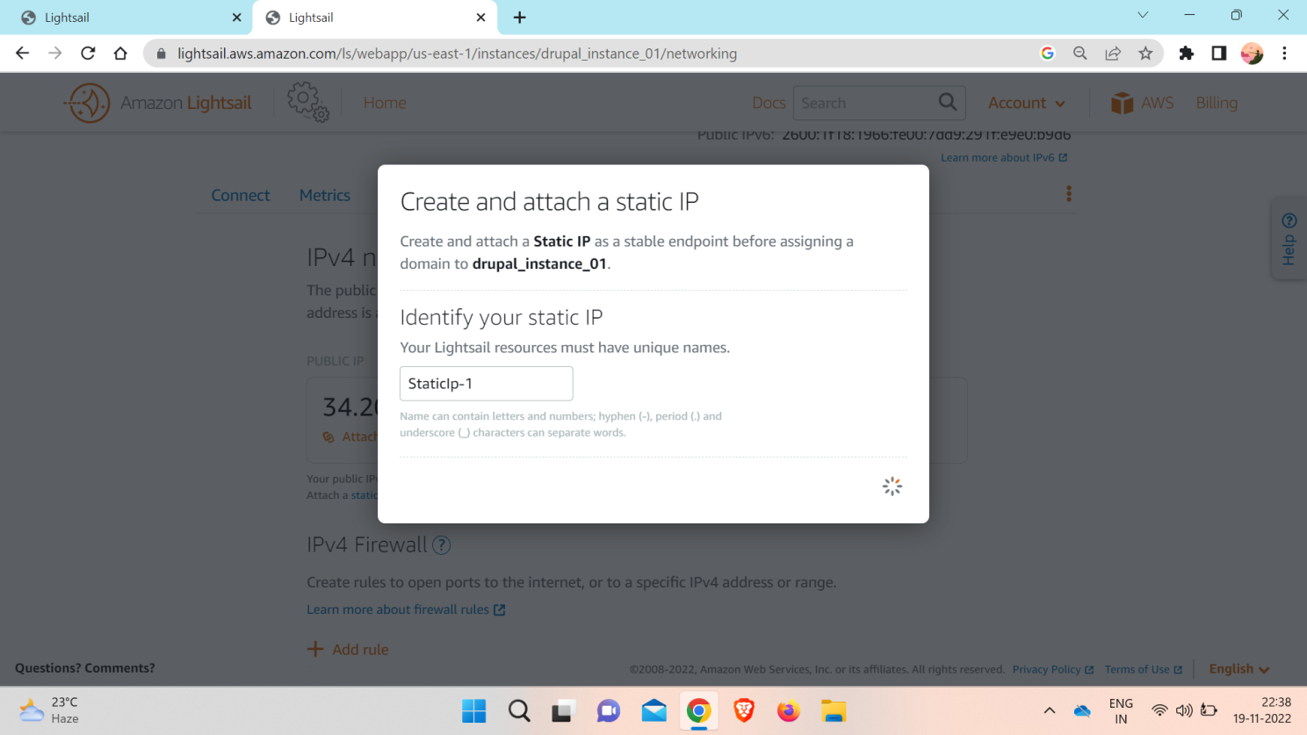

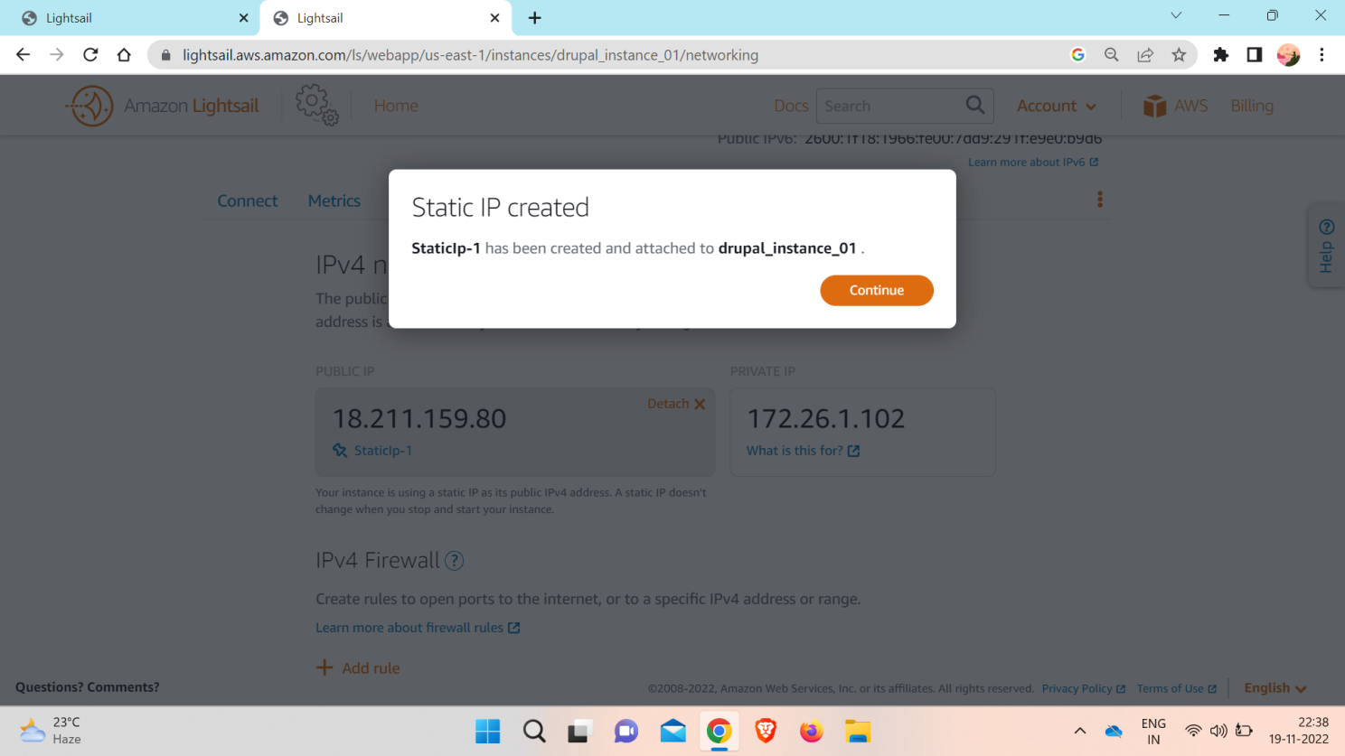Click continue

Step 6:- Create a Lightsail DNS zone and map a domain to your Drupal instance.

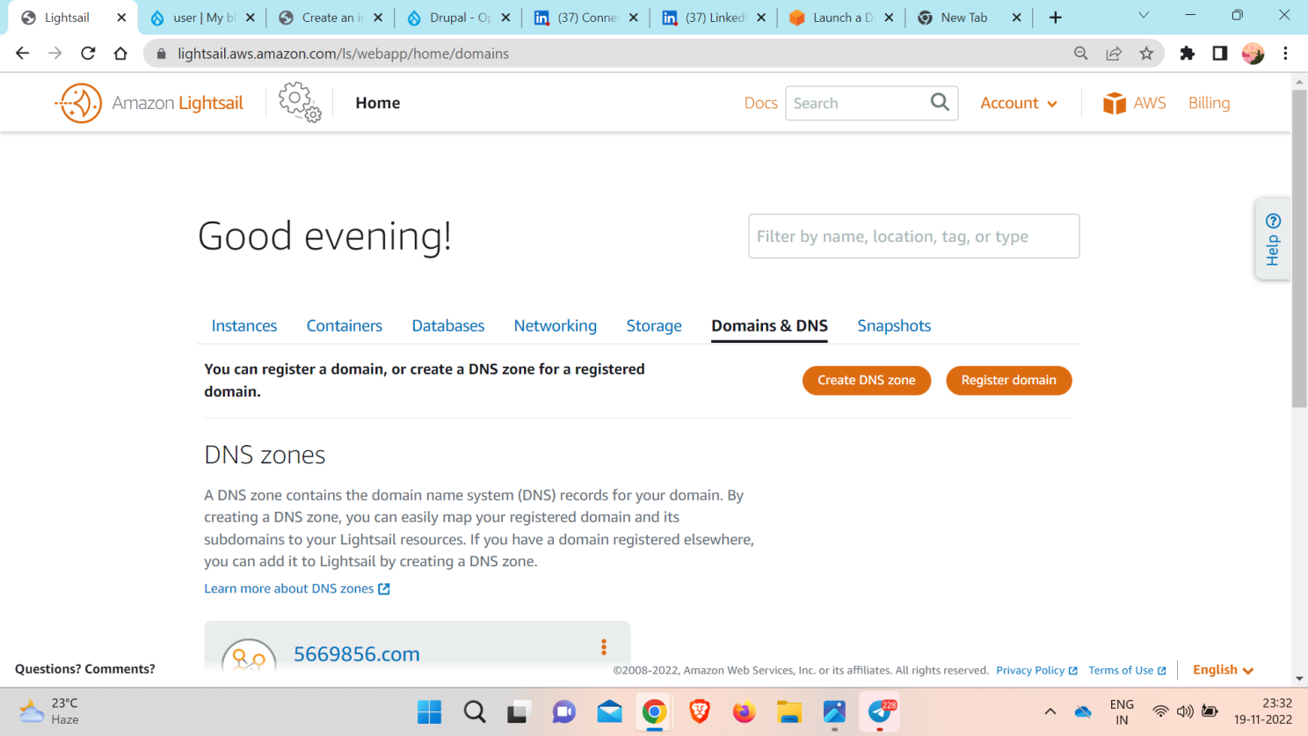

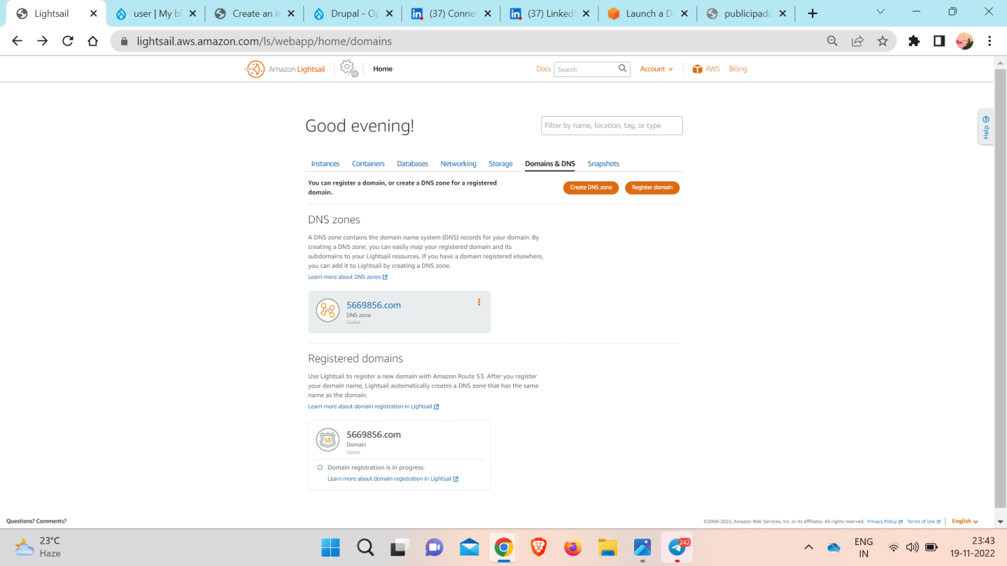

DNS records

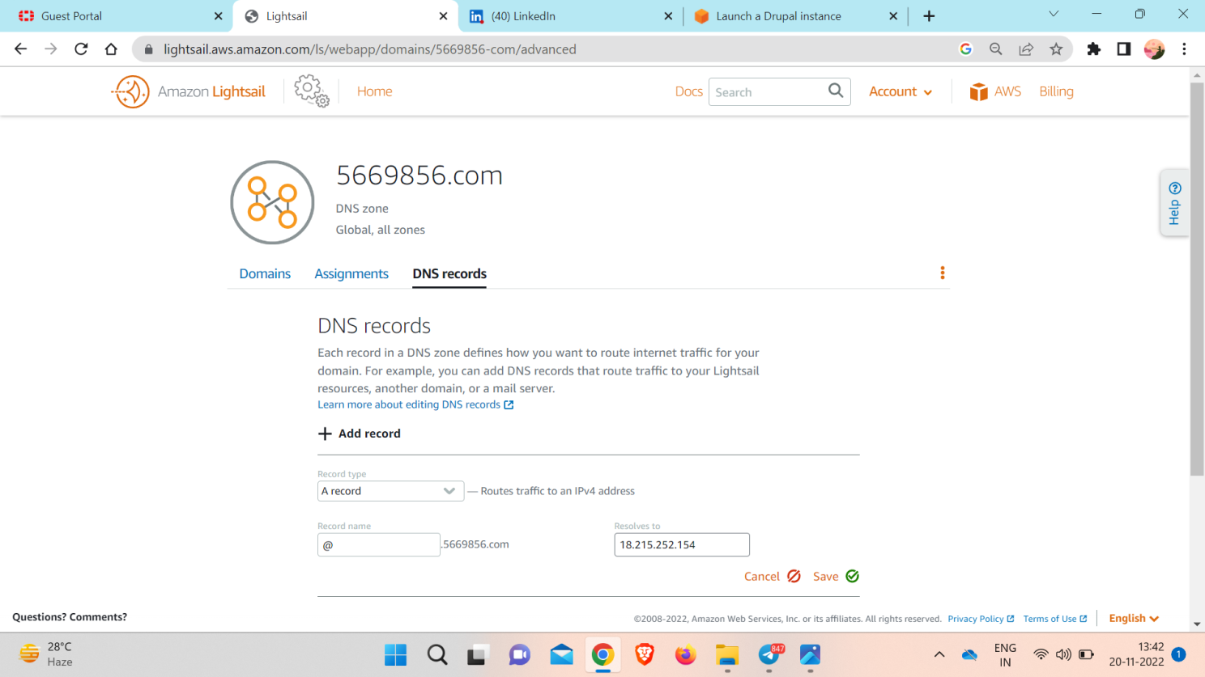



**Conclusion:-**Finally sucessfully launched Drupal instance.